Assignment-26.5:

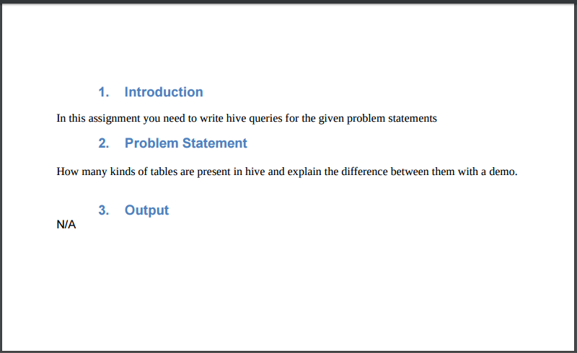

There are two types of tables in Hive:

1. Managed table:

If a managed table is dropped, the data as well as the metadata are deleted.

2. External table.

If an external table is dropped, only metadata is deleted

Creating the Managed table:

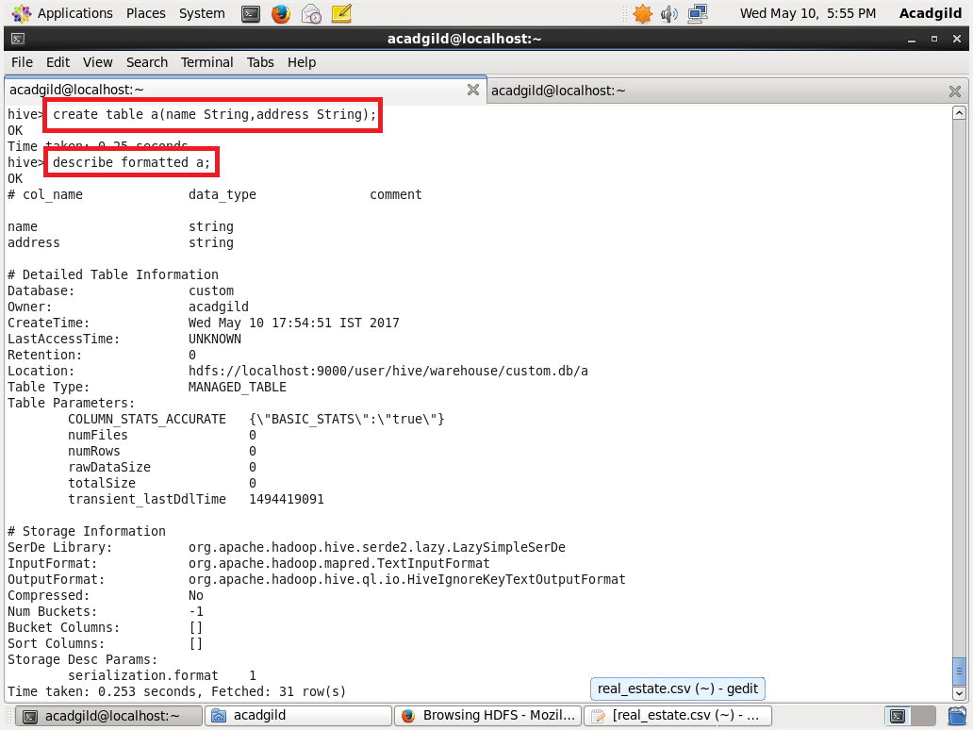

Creating the external table:

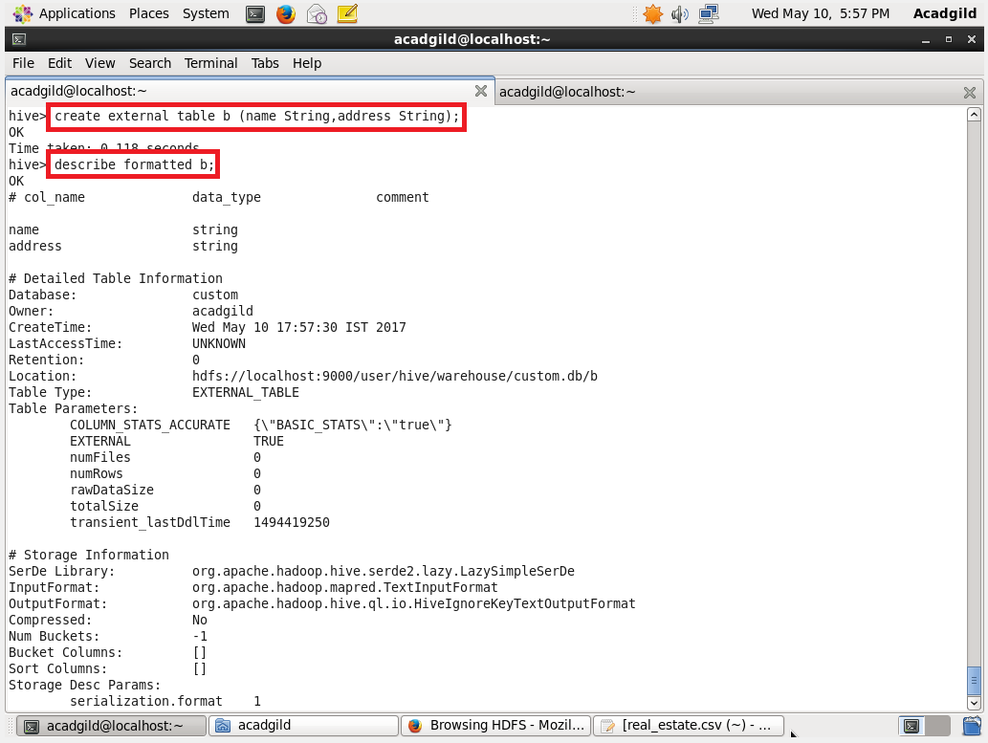

Dropping the managed table:

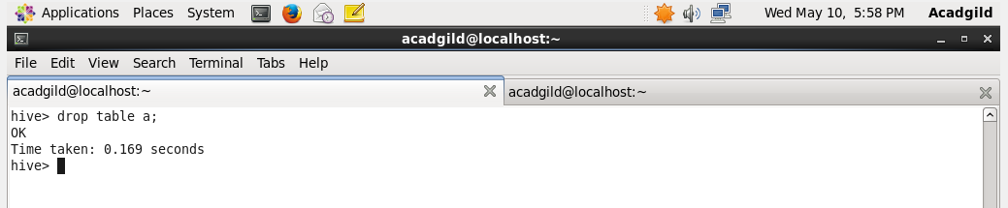

Dropping the external table:

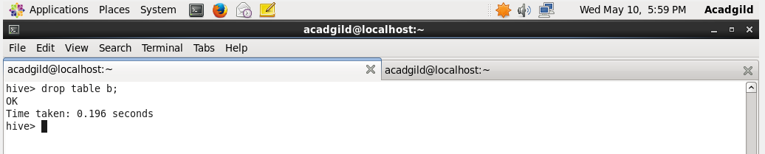

Displaying the directories:

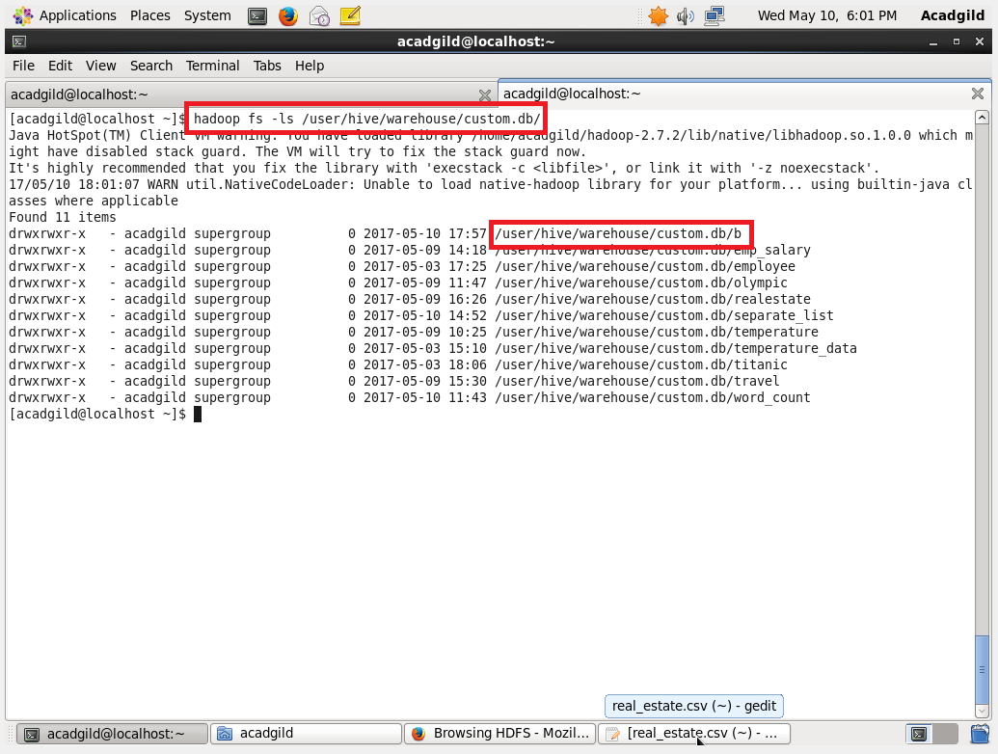

We can see from the above screenshot, the external table ‘b’ is still present and the managed table ‘a’ is gone.